Machine Learning – CSE 6363
Assignment 2 Report

Documented by: Manan Arora (1002143328)

Introduction:
For this assignment, I have implemented the LeNet-5 CNN architecture using PyTorch and trained it on the MNIST dataset. LeNet-5 is a classic CNN architecture originally developed for handwritten digit recognition, which makes it suitable for MNIST—a dataset of 28x28 grayscale images of handwritten digits (0-9). The goal was to achieve high accuracy on this dataset while tracking the training loss, confusion matrix, and overall test accuracy to analyze the model’s performance.

Results

Training Loss Over Epochs
The model was trained over 10 epochs with a batch size of 64 and a learning rate of 0.001. The training loss decreased steadily with each epoch, indicating that the model was learning effectively. Here is a plot of the training loss over the epochs:
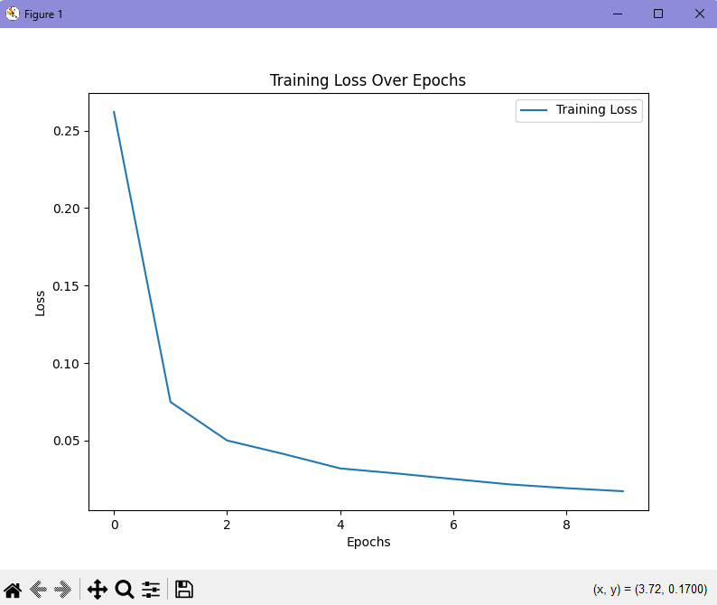
From this plot, we can see a rapid drop in the initial epochs, followed by a gradual reduction, which is typical for neural networks as they converge towards optimal weights.

Confusion Matrix
After training, I evaluated the model on the test set, generating a confusion matrix to understand its performance across different classes:
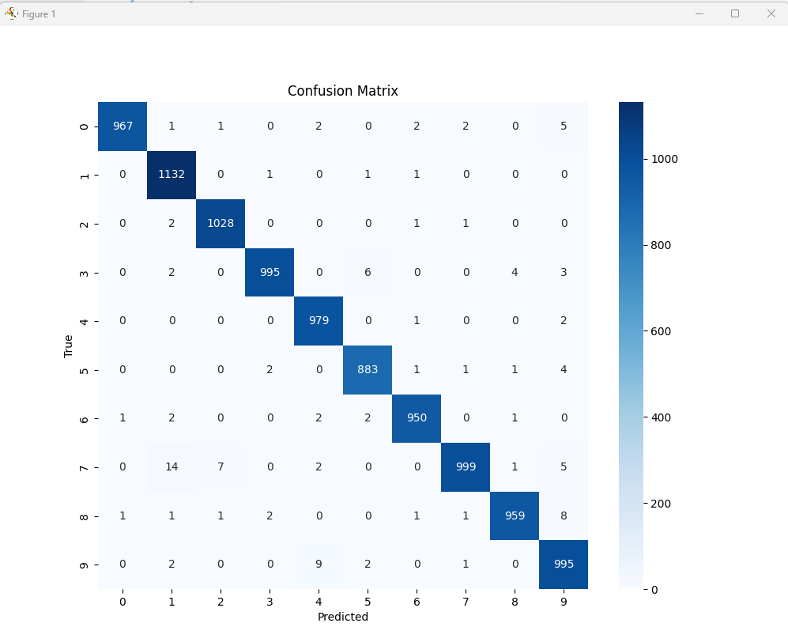
The confusion matrix shows that the model achieved near-perfect classification for most digits, with minor misclassifications. For example, there were some misclassifications between classes such as '9' and '7', which are visually similar.

Test Accuracy
The model achieved a test accuracy of 98.87% on the MNIST dataset. This high accuracy demonstrates the effectiveness of the LeNet-5 architecture for digit recognition tasks. Below is the epoch-wise training output that highlights the loss at each stage:
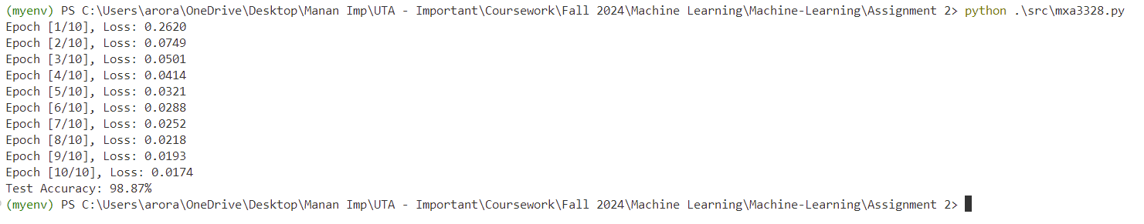

Analysis
The results indicate that LeNet-5 is well-suited for the MNIST dataset, with strong accuracy and minimal misclassification. The rapid reduction in loss during early epochs suggests that the network quickly learned meaningful features from the dataset. The confusion matrix further highlights the model’s robustness, showing that it correctly classified most digits with minimal overlap. The occasional misclassifications are likely due to similar pixel structures between certain digits, such as '4' and '9'.
Overall, the model's accuracy and performance metrics reflect the classic CNN design's suitability for image classification tasks, especially those with relatively simple, uniform images like MNIST.

Conclusion
The pytorch implementation of LeNet-5 model achieves impressive results on the MNIST dataset, with a final test accuracy close to 99%. This project demonstrated the power of CNNs for image recognition and classification tasks, particularly when applied to structured datasets like MNIST. The decreasing training loss and higher test accuracy confirms that the model successfully learned distinguishing features of handwritten digits, providing valuable insights for similar future applications.

